Grade 6 Flight Webquest
Bernoulli’s Principle Notes

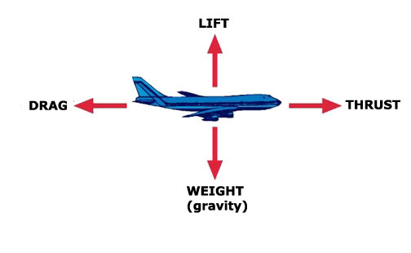
- What do each of the four forces on an airplane do?

Drag:

Weight:

Lift:

Thrust:
**Watch the video for more explanation. Record anymore notes for yourself in point form you think are important.

- Beroulli’s Principle (define):

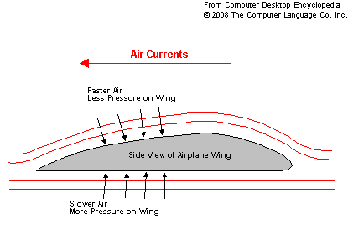
- The ________________ of a wing creates a longer distance from front to back than the straight bottom. This causes the _______on top to travel ___________, and thus __________, to reach the back than the air underneath, creating a difference in ____________ between the two surfaces.

- Who was Bernoulli?

- Why does the ping pong ball stick to the bottle? What is occurring?

- Read over the History of Flight. Complete the activity (you will need to complete a Research sheet and Biography sheet. When you have completed these print them off.

