On a dark, clear night, a first glance at the sky might reveal hundreds of stars. Look a little closer, and it might seem like some stars appear to form patterns. You can see these patterns night after night, year after year. In fact, people around the world have been studying and naming star patterns for thousands of years. These star patterns are called constellations.
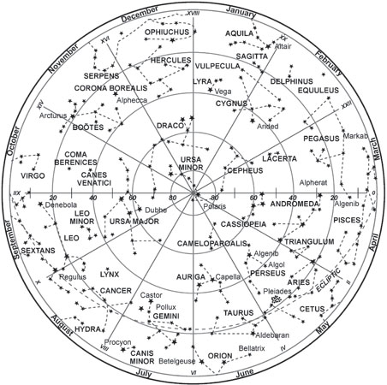
There are 88 constellations recognized by the International Astronomical Union (IAU). Many of these were mapped out by the ancient Greeks thousands of years ago.

A star map of the northern sky

There are also many unofficial star groups called asterisms. The stars in an asterism, like a constellation, form a recognizable pattern in the sky. However, an asterism could be a small part of a larger constellation or could contain stars from more than one constellation. One of the most well-known groups of stars, the Big Dipper, is an asterism. It is part of a much larger constellation called Ursa Major, or the Great Bear. Another familiar asterism is the Summer Triangle. It is made up of three bright stars from three constellations—Cygnus the Swan, Aquila the Eagle, and Lyra the Harp.
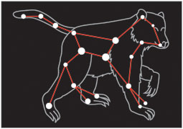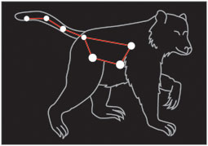
Ursa Major, the Great Bear The asterism, Big Dipper

Constellations and asterisms are useful markers in the sky. When people are new to viewing the night sky, they often look for these familiar groups of stars to help them find other stars and objects.

It is important to remember that the stars in a constellation often do not have any relationship to each other in outer space. In fact, most of the stars in a constellation are often light years away from each other. If you viewed the same stars from a different part of the galaxy, you would probably not see the same star patterns.

If you spend any amount of time watching the stars, you will see that all the stars appear to move across the night sky—except for one. This star is Polaris. Polaris can be found in the northern part of the sky. Because it does not move, Polaris has been used for navigation. If you are facing Polaris, sometimes called the North Star, you are looking north.

Some constellations can be seen year round. These are called circumpolar constellations. Each night, the circumpolar constellations circle around a single point. They are always visible. The point they circle around is Polaris, or the North Star. The main circumpolar constellations include the Great Bear (Ursa Major), the Little Bear (Ursa Minor), and Cassiopeia. Some other constellations that appear to move around Polaris are Draco the Dragon and Cepheus.
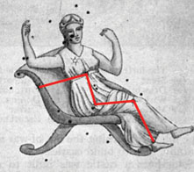
Cassiopeia is easily recognizable because of the distinctive W-shaped asterism formed by five bright stars.

Find the North Star
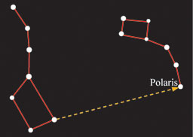
The next time the sky is clear at night, go outside and try to find Polaris, the North Star. First, look for the Big Dipper. Find the two stars that make up the right side of the Big Dipper’s cup. These two stars point toward Polaris, which is part of the Little Bear, or Ursa Minor.

The two stars on the right side of the Big Dipper’s cup point to Polaris, which is in the constellation the Little Bear

Not all constellations are visible every night. Depending on the time of year, you can expect to see different constellations. Leo the Lion, Hercules, and Cygnus the Swan are visible during the summer months. In the winter, look for Orion and Taurus the Bull.

Most of the constellations that are recognized today were named by the ancient Greeks. They named them after legendary figures, animals, or gods. They also created myths about the constellations that are still told today.
One of these myths is about the constellation Orion. Orion the Hunter is one of the better known constellations in the sky. It consists of seven major stars, two that form his shoulders, two that form his feet, and three that form his belt.

Orion

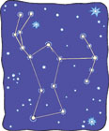
Greek legend states that Artemis, the goddess of the moon and hunting, fell in love with Orion, the bravest hunter of ancient times. According to the myth, Artemis drove a moon chariot across the sky at night. She began to neglect these duties in order to help Orion with his hunting on Earth. When Artemis’ brother Apollo heard this, he decided to trick Artemis into accidentally killing Orion from far away. When she realized what had happened, Artemis put Orion’s body into the darkest part of the sky. The sky became bright with stars that outlined his body.

The ancient Greeks were not the only people to develop legends based on the stars. Many First Nations cultures developed art, architecture, and stories that wove the stars and planets into their daily lives. Stories relating to constellations helped explain their positions in the sky. The Iroquois called the Big Dipper the Great Bear. Three stars in the constellation were thought to be hunters chasing the bear, one with a weapon, one with a pot for cooking, and the last with firewood. By the time the Big Dipper moved across the sky, it was in a different position, which symbolized the success of the hunters. Some other groups, however, believed that the three stars were cubs following the mother bear.

